www.agtagenomics.org.au
A.B.N. 45 833 973 608

Incorporated Association (VIC)
Registry No. A0046227B

C/- Dr. Mark Waltham
St. Vincent’s Institute Medical Research
29 Regent St, Fitzroy, Vic 3065, Australia

EMAIL: info@agtagenomics.org.au
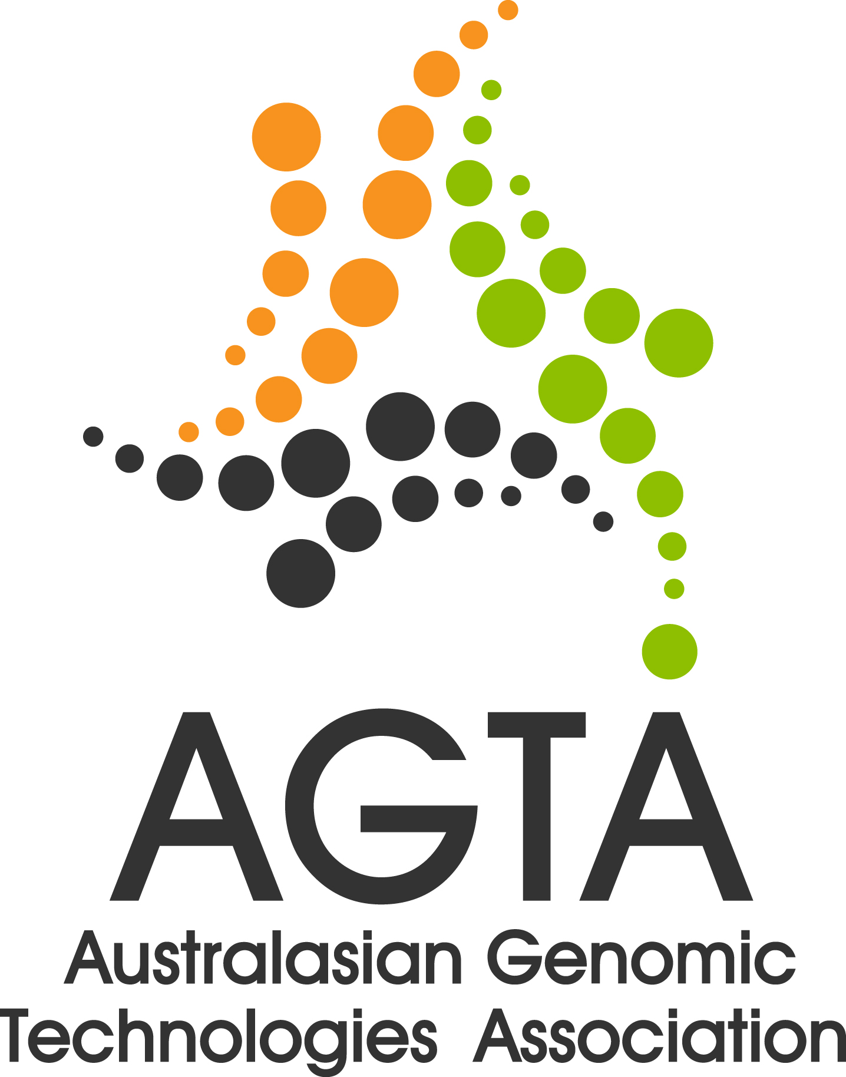

small grant scheme 2013

PART 1: Objectives, review and administration of the scheme.

(a) What is the objective of the small grants scheme?
- Promote the activities of AGTA and the Association’s charter
- Serve in the national interest in genomics through the dissemination, application and access to genomic technologies across Australia and New Zealand
- Improve education relating to the analysis of genomic data
- Build and broaden representation within the AGTA membership

(b) What types of grants and amounts are likely to be awarded?
Funded amounts are up to $5,000 per applicant. Matching funds from the applicant’s institute or commercial companies are highly desirable. Two forms of activity are encouraged:

- Educational seminars and workshops on the application of new genomic technologies, and/or the associated data analysis and bioinformatics (e.g. a Galaxy workshop at an academic centre.) The budget may include flight costs and associated accommodation for interstate or Aus-NZ invited speaker(s).

- Evaluation of a new technology, with a comparison to an existing technique; (e.g. comparison of commercial kits for NextGen library preparation; Fluidigm vs. Nanostring expression profiling technology). In this instance the scheme would primarily fund reagent costs. A proposed and realistic plan to disseminate findings to the wider community is an essential component for such an application.

(c) Number of grants available and submission dates.
Up to 10 grants may be awarded, depending on the availability of funds.
Grant applications are open from 19th October 2013 with applications due by the 13th December 2013.

(d) How will applications be reviewed?
Applications will be reviewed by the current members of the AGTA Management Committee or invited external reviewers. Individuals with noted conflicts of interest shall not participate. Additional information from applicants may be requested. The merit of each proposal will be discussed and a subsequent vote system followed.

(e) How will success of the scheme be monitored?
A report of the outcomes of the project or workshop will be requested by the AGTA committee and will be highlighted at the Annual General Meeting of the association. This report may be published on the AGTA website. In some cases, a grant recipient may be invited to present the results of projects comparing technologies at AGTA’s annual national conference.
In the case of a technology comparison, the successful award of funds is conditional on approval by the AGTA committee who will base their decision on the scientific quality and technical relevance of the outlined work and gauge its likelihood of success.
In the case of an organized workshop or symposium, feedback from the organizers will be required detailing the number of participants expected to be involvement and the outcomes anticipated. It is a condition of the award that workshop or symposium participants will be provided opportunities to become members of AGTA. Over the long term, it is hoped that the success of the grants scheme will be evident from increased AGTA subscriptions, AGTA conference participation and enhanced AGTA web access metrics.

(f) Eligibility of applicants
The principal applicant should be an Australian or New Zealand resident and a financial member of AGTA. Brief details of academic achievement of the Principal Applicant over the last five years will be requested in the application. Please note that early career scientists are particularly encouraged to apply. Associated applicants are not required to be members of AGTA, but their membership is encouraged.

(g) Transfer of funds
Funds will be remitted by the AGTA Treasurer following ratification by the Management Committee with payment being directed to the sponsoring institution of principal applicant. It is expected that funds will be used within one year of receipt, else will be required to be paid back to AGTA.

(h) Instructions to applicants
Applications should be prepared as a single pdf document, addressing the questions listed in the Application Form. Whilst figures and diagrams are welcomed, the final document should be less than 3MB size. Text should be 12-font size and word limits should be strictly adhered to.

(i) Lodging the application
Email completed application and accompanying information as a single pdf file to AMATA secretary (marshall.vikki@gmail.com) by 5pm Friday 13th December 2013

www.amata.org.au
A.B.N. 45 833 973 608

C/- Prof Erik Thompson
University of Melbourne, Department of Surgery
29 Regent St, Fitzroy, Vic 3065
Australia

A.B.N. 45 833 973 608

small grant scheme 2013/14 application form

A- TITLE OF PROPOSAL (200 characters max)

B- PRINCIPAL APPLICANT DETAILS

Name
Affiliation
Email address
Contact No. |  | AGTA Member  No.
Biography / Track record of Principal Applicant (2000 characters max)
C - ASSOCIATE APPLICANT DETAILS
1.
Name
Affiliation
Email address
Contact No.
2.
Name
Affiliation
Email address
Contact No.

D- ADMINISTERING INSTITUTION
Funds must be administered via an institution and will not be paid directly to the successful applicant
Institute Name
Primary Administrative Contact Name
Email address
Contact No.

E- JUSTIFICATION FOR AGTA TO FUND THIS INITIATIVE
How do you envision this activity will promote the goals of AMATA?

If funded, how will the success of this proposal be gauged?

F – PROJECT DESCRIPTION
Describe how the funds will be used (1 page maximum)
Please include a brief statement on the roles of Principal Applicant and Associate Applicants

G - BUDGETARY INFORMATION
Has co-funding been secured or sought for this application? | Yes / No
Proposed budget (1/2 page maximum)

How will any project costing short falls be meet?

H - ADDITIONAL RELEVANT INFORMATION

Please attach any additional reference information you consider may help AMATA assess the merits of this application.

J: AUTHORISATIONS
The application form must be signed by the principal applicant, who assumes responsibility for the progress and outcomes of the project on behalf of all associated applicants.

The application form must be signed by the Head of the Administrating Institution, or their delegated representative, indicating their support for the proposal being funded through this scheme.

PRINCIPAL APPLICANT SIGNATURE  DATE | / /
ADMINISTERING INSTITUTION SIGNATURE  DATE | / /

Email completed application and accompanying information as a single pdf file to AMATA secretary (marshall.vikki@gmail.com) by 5pm Friday 13th December 2013

