www.agtagenomics.org.au

Contact & submission to:
AGTA Secretary
info@agtagenomics.org.au

A.B.N. 45 833 973 608

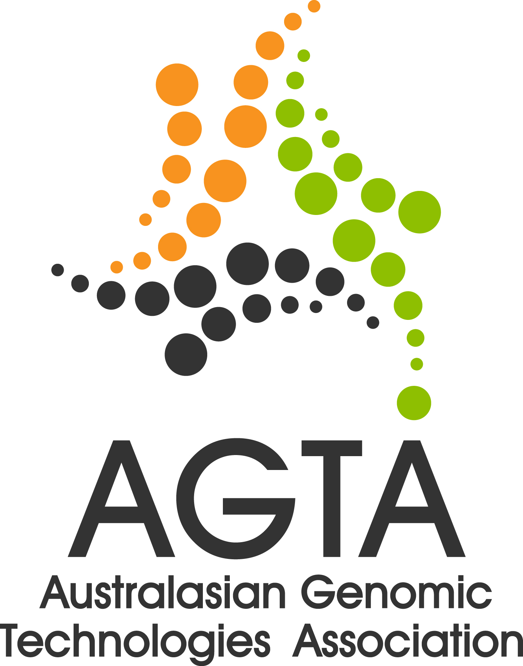

small grant scheme 2017/18 application form

A- TITLE OF PROPOSAL (200 characters max.)

B- PRINCIPAL APPLICANT DETAILS

Name
Affiliation
Email address
Contact No. |  | Please confirm that you are  an AGTA member: Yes/No
Biography / Track record of Principal Applicant (2,000 characters max.)

C - ASSOCIATE APPLICANT DETAILS (Add additional boxes if necessary)
1.
Name
Affiliation
Email address
Contact No.
2.
Name
Affiliation
Email address
Contact No.

D- ADMINISTERING INSTITUTION
Funds must be administered via an institution and will not be paid directly to the successful applicant
Institute Name
Primary Administrative Contact Name
Email address
Contact No.

E- JUSTIFICATION FOR AGTA TO FUND THIS INITIATIVE
How do you envision this activity will promote the goals of AGTA? (600 characters max)

If funded, how will the success of this proposal be gauged? (800 characters max)

F – PROJECT DESCRIPTION
Describe how the funds will be used (4,000 character maximum)
Please include a brief statement on the roles of Principal Applicant and Associate Applicants

Has co-funding been secured or sought for this application? | Yes / No
Proposed budget (1/2 page maximum). Please consult application instructions (Section e) and note that any residual funds are expected to be returned to AGTA on completion of the project.

How will any project costing short falls be covered? (600 characters max)

G - BUDGETARY INFORMATION

H - ADDITIONAL RELEVANT INFORMATION

Please provide any additional information you consider may help AGTA assess the merits of this application (600 characters max). Note: Additional pages of support material (for example recent publication) but not additional text from the applicant can be added to this document but entire submitted pdf must be less than 4 MB.

I - AUTHORISATIONS
The application form must be signed by the principal applicant, who assumes responsibility for the progress and outcomes of the project on behalf of all associated applicants.

The application form must be signed by the Head of Department of the Administrating Institution, or their delegated representative, indicating their support for the proposal being funded through this scheme.

CONTACT DETAILS OF FINANCIAL OFFICER AT YOUR INSTITUTION | NAME:  EMAIL:  PHONE NO.
PRINCIPAL APPLICANT SIGNATURE  (electronic signature acceptable)  DATE | / /
ADMINISTERING INSTITUTION SIGNATURE  (electronic signature acceptable)  DATE | / /

Email completed application and accompanying information as a single pdf file (less than 4 MB) to the AGTA secretary (info@agtagenomics.org.au) by 11.59 pm, Monday 22nd January 2018.

